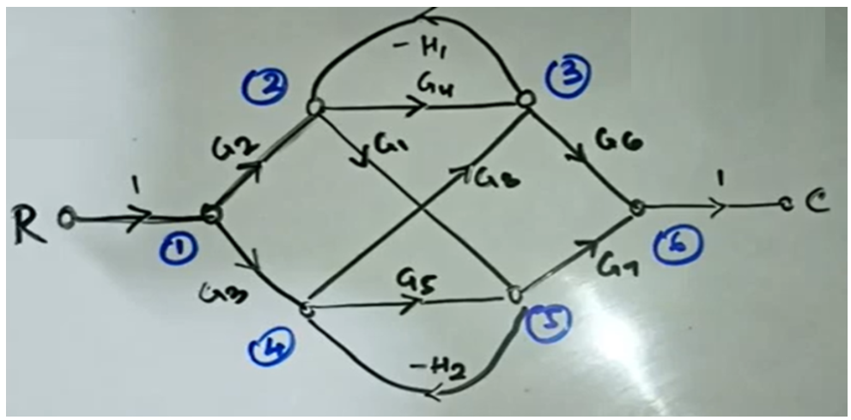

**Q: Apply The Mason Gain Formula to Find the Transfer Function from the Figure given above?**

**SOLUTION**

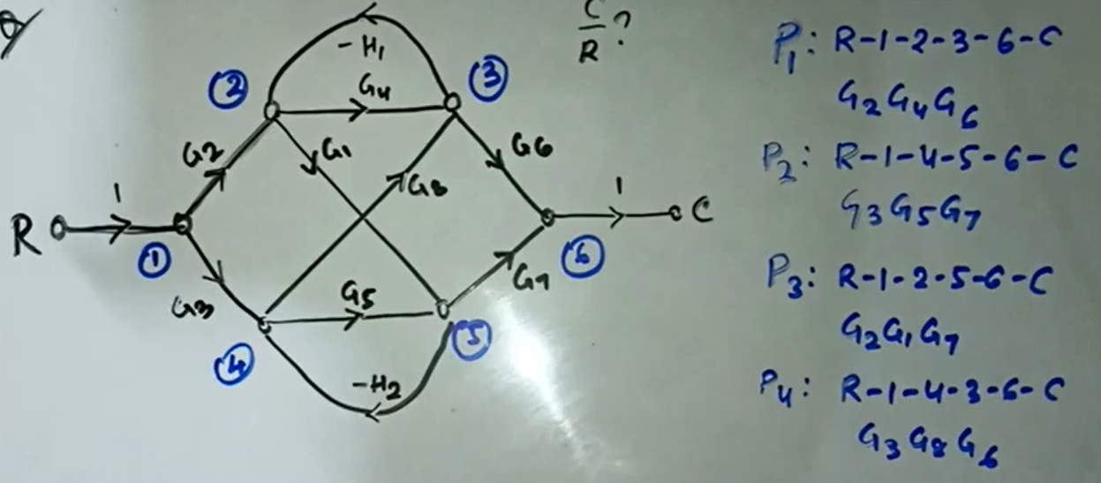

**FORWARD PATH AND ITS GAIN**

**P1: R→1→2→3→6→C**

**GAIN: G2 G4 G6**

**P2: R→1→4→5→6→C**

**GAIN: G3 G5 G7**

**P3: R→1→2→5→6→C**

**GAIN: G2 G1 G7**

**P4: R→1→4→3→6→C**

**GAIN: G3 G8 G6**

**P5: R→1→2→5→4→3→6→C**

**GAIN: -G2 G1 H2 G8 G6**

**P6: R→1→4→3→2→5→6→C**

**GAIN: -G3 G8 H1 G1 G9**

**FIND LOOPS AND ITS GAIN**

**L1: 2→3→2**

**GAIN: -G4 H1**

**L2: 4→5→4**

**GAIN: -G5 H2**

**L3: 3→2→5→4→3**

**GAIN: G1 G8 H1 H2**

**NON-TOUCHING LOOP**

**For Non-Touching Loop check the values**

|  |  |  |  |
| --- | --- | --- | --- |
| **Forward Path** | **Loops** | **Checking** | **Non-Touching** |
| **P1: R→1→2→3→6→C** | **L1: 2→3→2**  **GAIN: -G4 H1** | **It is touching because from P1 and L1 values of 2 and 3 is common** |  |
| **L2: 4→5→4**  **GAIN: -G5 H2** | **Yes Non-Touching available** | $${∆ }_{2} =1-(-G_{5}H_{2})$$ |
| **L3: 3→2→5→4→3**  **GAIN: G1 G8 H1 H2** | **It is touching because from P1 and L3 values of 2 and 3 is common** | $${∆ }_{3}=1-\left(0\right)=1$$ |
| **P2: R→1→4→5→6→C** | **L1: 2→3→2**  **GAIN: -G4 H1** | **Yes Non-Touching available** |  |
| **L2: 4→5→4**  **GAIN: -G5 H2** | **It is touching because from P2 and L2 values of 4 and 5 is common** | $${∆ }_{5}=1-\left(0\right)=1$$ |
| **L3: 3→2→5→4→3**  **GAIN: G1 G8 H1 H2** | **It is touching because from P2 and L3 values of 4 and 5 is common** | $${∆ }_{6}=1-\left(0\right)=1$$ |
| **P3: R→1→2→5→6→C** | **L1: 2→3→2**  **GAIN: -G4 H1** | **It is touching because from P3 and L1 values of 2 is common** |  |
| **L2: 4→5→4**  **GAIN: -G5 H2** | **It is touching because from P3 and L2 values of 5 is common** | $${∆ }_{8}=1-\left(0\right)=1$$ |
| **L3: 3→2→5→4→3**  **GAIN: G1 G8 H1 H2** | **It is touching because from P3 and L3 values of 2 and 5 is common** | $${∆ }_{9}=1-\left(0\right)=1$$ |

**Now Non Touching Loop = ${L }_{2}at {P }_{1} *{L }_{1}at {P }_{2}=\{-G5 H2\}\{-G4 H1\}= G4G5 H1H2$**

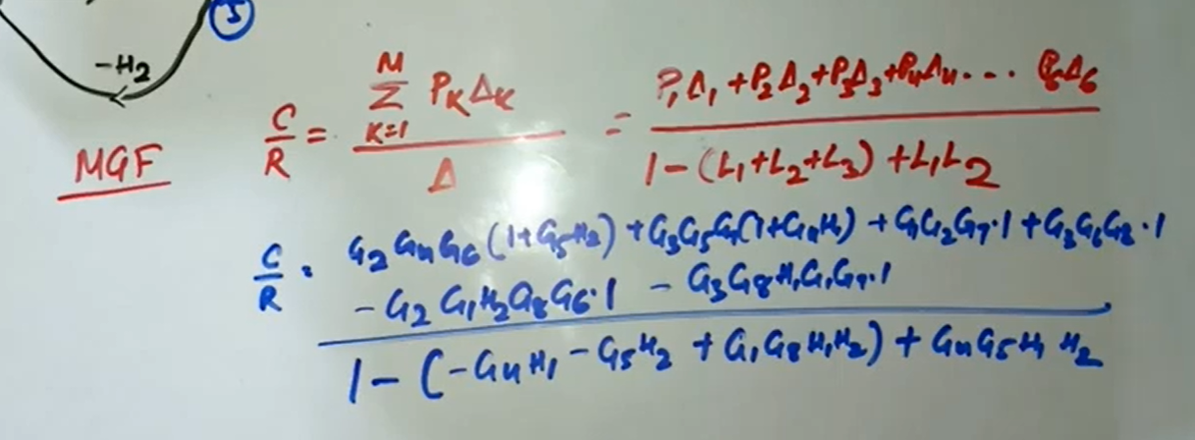

**NOW APPLY MASON GAIN FORMULA TO CALCULATE THE TRANSFER FUNCTION**

**G2 G4 G6**